# Memorandum

**To:** Bruce [last name redacted]

**From**: Dave Simon

**Date:** September 8, 2023 (updated November 8, 2023)

**Re:** Dairy and the Five Precepts

Bruce, thanks for agreeing to read these thoughts on dairy and the five precepts. I’ve had these issues on my mind since May, when I attended a 10-day Vipassana retreat at Dhamma Manda. I was aware (and glad) that we would be asked to follow the five precepts. And when I saw a humane bug catcher in the hallway of my residence building, I was impressed at the level of compassion that would spur people to make and distribute such devices throughout the center. However, based on what I know of dairy farming practices, when I saw dairy served at meals, that seemed inconsistent with the precepts, the bug-catcher, and other themes of compassion I encountered during the retreat.

The main point of this memo is that times have changed, and dairy production methods that 50 or 60 years ago seemed humane have evolved into practices that routinely cause pain or death to mother and calf. These changes in production methods urge a fresh look at the idea that diary production is humane and consistent with the five precepts. In fact, it seems clear that modern dairy production methods, and the narrative surrounding these methods, violate at least three of the precepts (killing, stealing and lying) and arguably also violate the other two (sexual misconduct and intoxicants).

1. **The first precept** – to abstain from killing (sometimes also expressed as a prohibition against causing harm). Dairy farming violates this precept in several ways:
   1. Dairy cows have a natural lifespan of 20 years. However, they are typically slaughtered at the age of four or five when they cease to be productive.
   2. Male calves born into the dairy industry have little value and no place in dairy production and are typically discarded or slaughtered for veal within 20 weeks of birth. They’ll spend their short life alone, without a mother, often in a “veal crate” like this:

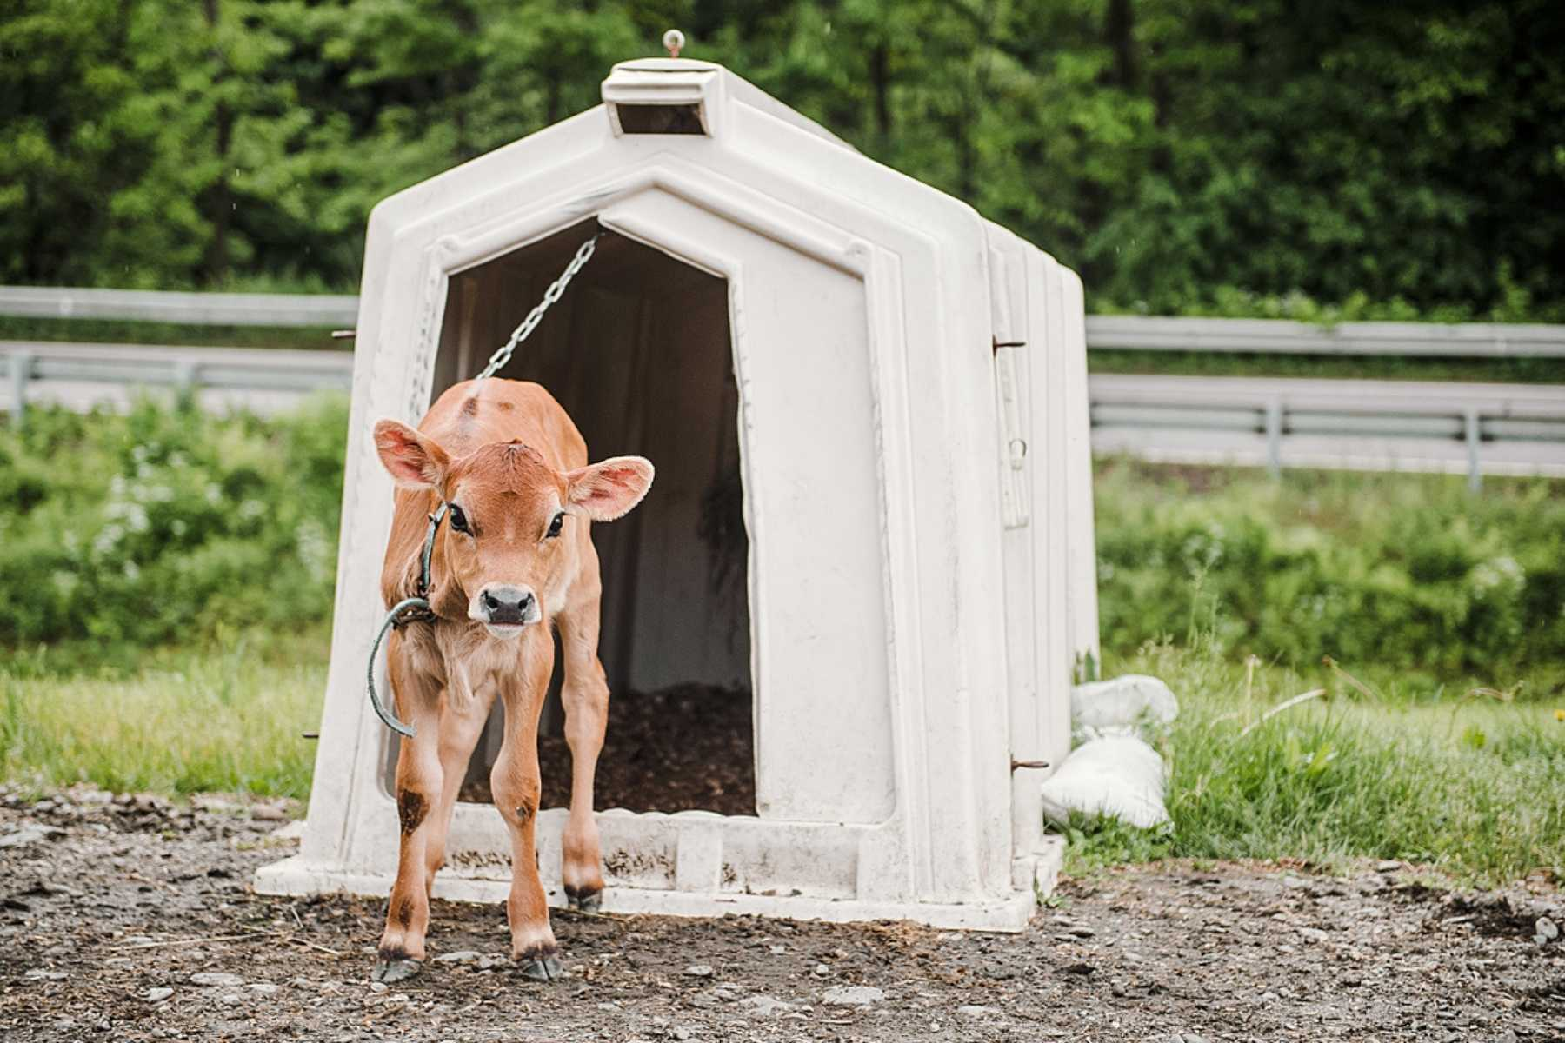

* 1. Dairy cows are typically subjected to various forms of painful mutilation, such as branding, tail docking, and dehorning. All of these are painful. Studies find dehorning, for example, causes “acute and prolonged pain.” A few dehorned cows:

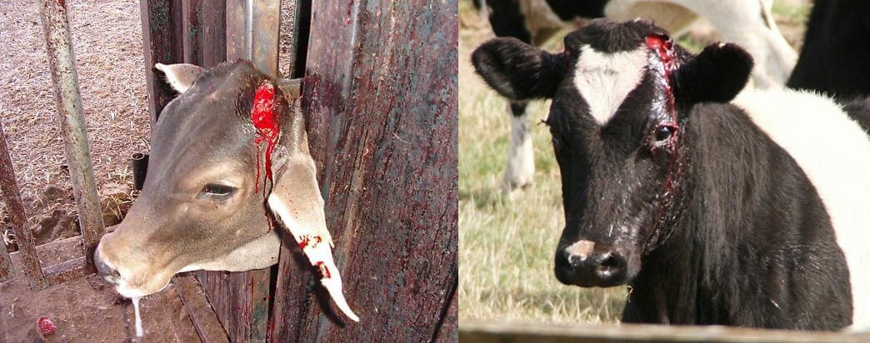

* 1. Most U.S. dairy cows will spend their entire lives indoors, hyper-confined to tiny concrete stalls like those below. Yet not surprisingly, research shows that cows, like people, don’t like being confined inside and prefer to be outdoors.

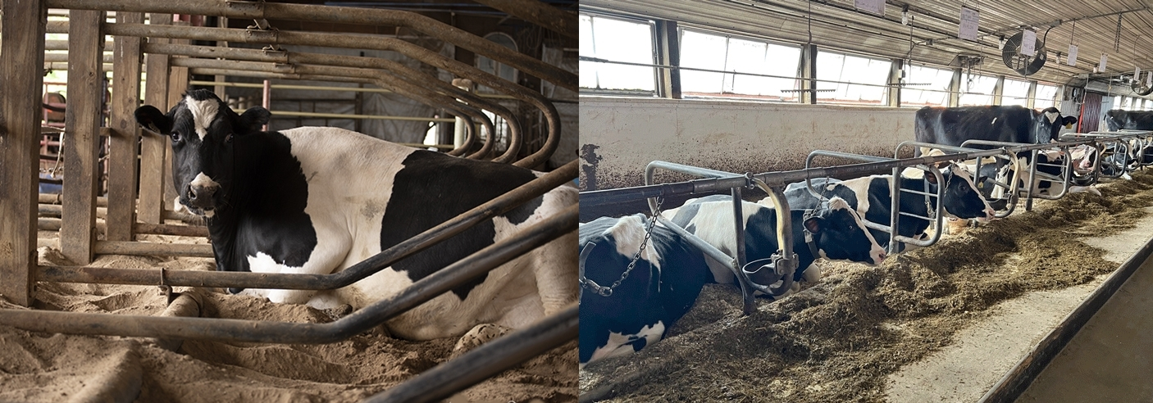

1. **The second precept** – to abstain from stealing. Dairy violates this precept in two ways.
   1. First, calves are literally stolen from their mothers. Because mammals (i.e., animals with mammary glands) form strong bonds around the practice of nursing their young, separating lactating cows from their calves is emotionally quite painful for the mothers and their calves. This short [video](https://www.youtube.com/watch?v=HqgDaOetQoU) illustrates some of these effects.
   2. Second, a cow’s milk, which is intended for her calf, is taken from her – and the calf is fed formula instead. To deter calves from trying to breast feed, they are often fitted with “weaning rings” like these that make it painful and physically impractical to nurse:

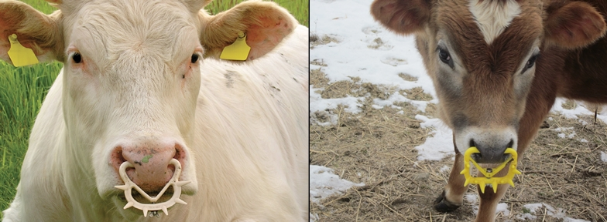

1. **The third precept** – to abstain from sexual misconduct. Because dairy cows only produce milk when they’re lactating, they must be kept in a perpetual state of pregnancy. This requires that they be regularly artificially inseminated. The dairy industry itself coined the term “rape rack” to describe a device used to restrain a cow being inseminated. (I prefer to avoid the term “rape,” which is nevertheless used by the dairy industry itself.) Research into cows’ cortisol levels shows that, not surprisingly, artificial insemination cause stress to the animals. Thus, artificially inseminating a cow to make milk is arguably an act of sexual misconduct that violates the third precept. A few examples of these restraint devices in use:

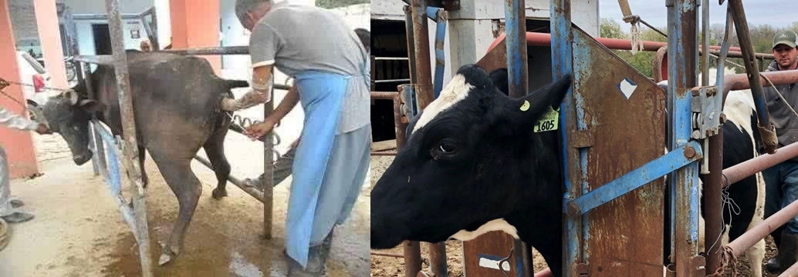

1. **The fourth precept** – to abstain from lying. When the dairy industry tells us cows are treated humanely, as it does regularly, the overwhelming, contradictory evidence shows they are lying. And of course, if we tell one another that dairy is humane and consistent with the five precepts, we are arguably engaged in a lie as well – which also violates the fourth precept.
2. **The fifth precept** – to abstain from intoxicants. Cow’s milk contains small quantities of opiates, which researchers believe may be to encourage calves to keep coming back to nurse until they’re old enough to wean. These intoxicants can make dairy products – especially cheese, which contains especially high concentrations of opiates – mildly addictive to humans. Again, this intoxicating effect of dairy arguably violates the fifth precept.
3. **FAQ and Objections** – for those accustomed to consuming dairy, as I was for decades, this information can be overwhelming. One may be tempted to raise any of these frequently asked questions or objections:
   1. “Most dairy farms aren’t like that.”
      1. In fact, the Sentience Institute estimates that more than 70% of all dairy cows in the U.S. are raised in factory farms. The small family farm that once dominated the landscape has become the exception rather than the rule. Practically speaking, that means that whenever we consume any commercially available dairy product – milk, cheese, yogurt, butter or ice cream – the chances exceed 70% that we’re consuming the product of the miserable, harmful conditions described above. (By the way, conditions at smaller farms are not particularly humane either. Even at smaller farms, cows are slaughtered when they are no longer productive, mother and calf are separated at birth, and depending on the farm, some or all of the mutilations described above may be performed.)
   2. “These photos and stories aren’t believable. Farmers wouldn’t treat their animals that way.”
      1. I’ve omitted citations to sources in this memo for brevity and simplicity. However, every assertion above can be easily verified by simply googling it. Alternatively, I’d be happy to provide a version of this memo that incudes citations.
   3. “It’s too hard to ask people to give up dairy. People are used to their dairy products.”
      1. In fact, dozens of alternative, plant-based products are now available in virtually any supermarket in the U.S. These include many flavors of vegan cheese, milk, and ice cream; vegan butter, sour cream, cream cheese, and yogurt; and various other forms of vegan non-dairy products. Most of these are indistinguishable from the dairy-based versions. Frankly, it has never been easier to give up dairy.
   4. “Is it appropriate to say that dairy cows are ‘raped’? That seems like an exaggeration.”
      1. The word “rape” is indeed a loaded term perhaps best avoided in this discussion. It comes up mainly because the dairy industry itself coined the term “rape rack” to describe the equipment used to inseminate a cow. But even without using that particular term, it is clear cows are being artificially inseminated in ways that they are stressful (and thus harmful) to them and that they would not consent to if they had a choice. So it does not seem a stretch to label this behavior “misconduct,” nor, since it pertains to a cow’s sexual organs, to further label it “sexual misconduct.”
   5. “Many meditators have dietary beliefs tied to their religions or belief systems, such as keto, macrobiotic, ayurvedic, vegan, etc. It would be impossible to cater to all of these dietary beliefs at the Center, so vegetarian food seems a good compromise.”
      1. This memo does not aim to convert people to veganism, nor to denigrate any other dietary ideology or belief system. It merely aims to point out that if the goal of the Center is for meditators to align with the five precepts while in attendance, only veganism can actually accomplish this objective. This fact sets veganism apart from other dietary ideologies in a fundamental and important way.
   6. “Some commentators believe the goal of being a vegan is to confront non-vegans and force them to take a side, and to constantly force debate and keep the issue in the forefront. Some also believe the end goal of veganism is to end all animal agriculture.”
      1. Regardless of vegans’ goals, which are likely different in subtle ways for each vegan, this memo has only a single, narrow objective: to help the Center achieve its stated goal that meditators align with the five precepts during their meditation retreat. When they leave, just as some will go back to consuming alcohol and drugs, others will go back to consuming whatever foods they choose.
   7. “Don’t ‘humane certified’ and ‘no-kill’ dairy farms provide a humane alternative source for dairy products?
      1. Actually, and surprisingly, so-called “humane” farms are almost always abusive and cruel to animals in ways that rival practices in conventional factory farms. Many commentators have provided detailed analysis of the falsity behind “humane farming” claims, such as this website: <https://www.humanemyth.org/>.
   8. There are many different types of veganism. Since all vegans are not created equal, it would be difficult to implement a vegan diet at the Center.
      1. On the contrary, most vegans would say their diet is pretty simple. True vegans follow a diet that excludes any animal products. Some consume honey and some don’t, but this is a minor fact that few care much about. Some non-vegans consume animal-based ingredients like ghee, whey, or the like, but as consuming these things means those these people aren’t actually vegan, they don’t bear on the issue. The main point is that, because the undisputed, empirical evidence shows that production of virtually all animal products, including dairy, entails significant cruelty and harm to animals, the only dietary system truly consistent with the five precepts is a vegan diet. For that reason, if the Center sincerely desires that its meditators align with the five precepts while in attendance, veganism is the only dietary system that accomplishes this goal.
4. **Conclusion**. Decades ago, consuming dairy might have been consistent with the five precepts. But today, with the rise of factory farming, the evidence is overwhelming that dairy production and consumption violate all or most of the five precepts. Given the center’s aim of adhering to the precepts, and its practice of encouraging meditators to do so as well, I'd like to suggest switching to non-dairy alternatives during meals.

Thank you for taking the time to read this. I look forward to your thoughts.

D.R.S.